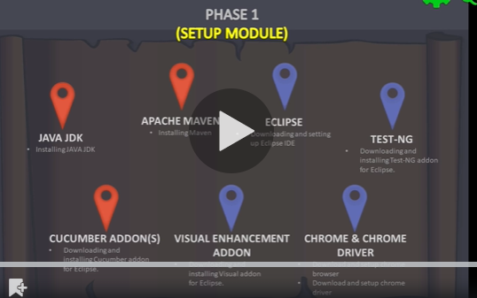
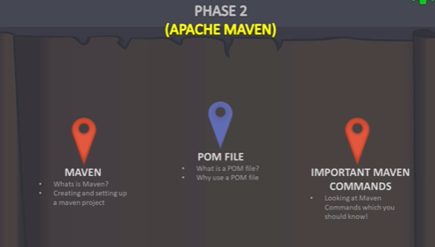
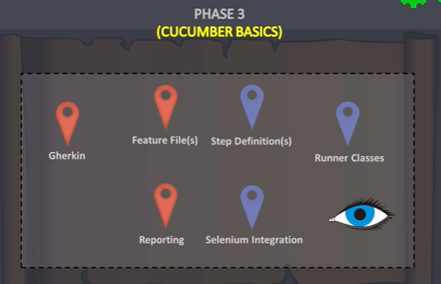
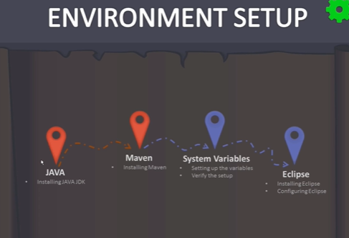
Download and install Java JDK
Set system variables
JAVA_HOME and give jdk folder path
Add jdk bin path in Path
Cmd java --version
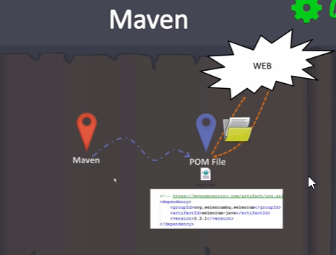
Download and install Maven (binary zip archive)
Set system variables
M2_HOME and give maven folder path
M2 maven bin folder path
Add %M2% to path
Cmd mvn -v

Eclipse download 64 bit
In set up click on Eclipse IDE for java developers and Install
Launch
Create a new Maven project
To align maven with eclipse
Windows Preferences Maven Installations Add Give the Maven folder path in installation home and give a name in installation name
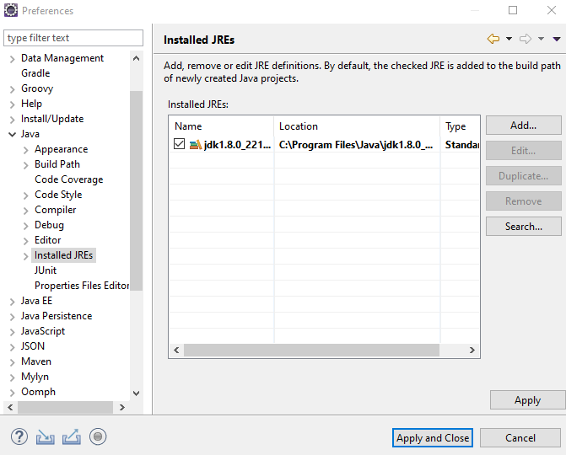
Installed JREs should point to java jdk instead of jre, change accordingly
In case of setting JRE definition
Give JDK path in JRE home
Give a name in JRE name
Default VM arguments should be -Dmaven.multiModuleProjectDirectory=M2_HOME
In case the project shows a problem like “Build path specifies execution environment…”
RC on the project Properties Order and Export Select the project Java build path Libraries Edit Alternate JREs Select JDK instead of JRE as we jut did in the previous step
The problem should be gone
In the Libraries page Add variable Select M2_REPO.
If u don’t have M2_REPO, configure variables new and give complete path of .m2\repository
To confirm if we have set up everything correctly
RC on POM.xml and Run as we should get all maven options mvn install we should get build success
Make sure that the maven compiler plugin code is added in pom.xml plugin management section
Updating the pom.xml updates the JDK config, make sure u update the project and the problems will be gone

Sample pom.xml to start with
<project xmlns="http://maven.apache.org/POM/4.0.0" xmlns:xsi="http://www.w3.org/2001/XMLSchema-instance"
xsi:schemaLocation="http://maven.apache.org/POM/4.0.0 http://maven.apache.org/xsd/maven-4.0.0.xsd">
<modelVersion>4.0.0</modelVersion>

<groupId>com.webdriveruniversity</groupId>
<artifactId>CucumberFramework</artifactId>
<version>0.0.1-SNAPSHOT</version>
<packaging>jar</packaging>

<name>CucumberFramework</name>
<url>http://maven.apache.org</url>

<properties>
<project.build.sourceEncoding>UTF-8</project.build.sourceEncoding>
</properties>

<build>
<pluginManagement>
<plugins>
<plugin>
<groupId>org.apache.maven.plugins</groupId>
<artifactId>maven-compiler-plugin</artifactId>
<version>3.1</version>
<configuration>
<source>1.8</source>
<target>1.8</target>
<fork>true</fork>
<!--<executable>C:\Program Files\Java\jdk1.8.0_121\bin\javac.exe</executable> -->
<executable>${env.JAVA_HOME}\bin\javac.exe</executable>
</configuration>
</plugin>
</plugins>

</pluginManagement>
</build>

<dependencies>
<dependency>
<groupId>junit</groupId>
<artifactId>junit</artifactId>
<version>3.8.1</version>
<scope>test</scope>
</dependency>
</dependencies>
</project>
To install TestNg

Help Maket place search for TestNg Install TestNg for eclipse
Junit is installed by default in eclipse
If we get TestNg option in create new, it means that TestNg is successfully installed
Help Maket place search for Cucumber Install Natural & Cucumber Eclipse plugin
https://cucumber.io/cucumber-eclipse/update-site for reference
Install Eclipse color theme and Darkest dark theme if required
Windows Preferences Change the font to sublime text 2
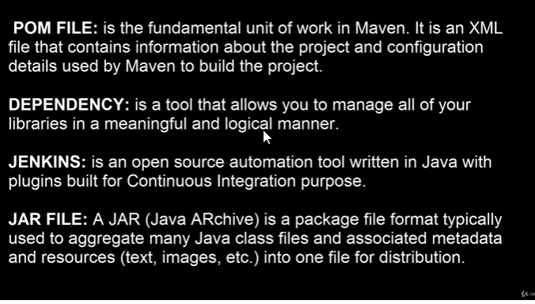

The jars will be downloaded from central repository to .m2/repository folder in local under Users
From the sample pom.xml given below for a cucumber project, copy from build down and force update the maven project or clean the project
Execution jdk
<build>
<pluginManagement>
<plugins>
<plugin>
<groupId>org.apache.maven.plugins</groupId>
<artifactId>maven-compiler-plugin</artifactId>
<version>3.1</version>
<configuration>
<source>1.8</source>
<target>1.8</target>
<fork>true</fork>
<!--<executable>C:\Program Files\Java\jdk1.8.0_121\bin\javac.exe</executable> -->
<executable>${env.JAVA_HOME}\bin\javac.exe</executable>
</configuration>
</plugin>
</plugins>
</pluginManagement>
</build>
Sample POM for cucumber project
<project xmlns="http://maven.apache.org/POM/4.0.0" xmlns:xsi="http://www.w3.org/2001/XMLSchema-instance"
xsi:schemaLocation="http://maven.apache.org/POM/4.0.0 http://maven.apache.org/xsd/maven-4.0.0.xsd">
<modelVersion>4.0.0</modelVersion>

<groupId>com.webdriveruniversity</groupId>
<artifactId>CucumberFramework</artifactId>
<version>0.0.1-SNAPSHOT</version>
<packaging>jar</packaging>

<name>CucumberFramework</name>
<url>http://maven.apache.org</url>

<properties>
<project.build.sourceEncoding>UTF-8</project.build.sourceEncoding>
</properties>

<build>
<pluginManagement>
<plugins>
<plugin>
<groupId>org.apache.maven.plugins</groupId>
<artifactId>maven-compiler-plugin</artifactId>
<version>3.1</version>
<configuration>
<source>1.8</source>
<target>1.8</target>
<fork>true</fork>
<!--<executable>C:\Program Files\Java\jdk1.8.0_121\bin\javac.exe</executable>-->
<executable>${env.JAVA_HOME}\bin\javac.exe</executable>
</configuration>
</plugin>
<plugin>
<groupId>org.apache.maven.plugins</groupId>
<artifactId>maven-surefire-plugin</artifactId>
<version>2.19.1</version>
<configuration>
<suiteXmlFiles>
<suiteXmlFile>testng.xml</suiteXmlFile>
</suiteXmlFiles>
<testErrorIgnore>false</testErrorIgnore>
<testFailureIgnore>false</testFailureIgnore>
</configuration>
</plugin>
</plugins>
</pluginManagement>
</build>

<reporting>
<plugins>
<plugin>
<groupId>org.apache.maven.plugins</groupId>
<artifactId>maven-surefire-report-plugin</artifactId>
<version>2.19.1</version>
</plugin>
</plugins>
</reporting>

<dependencies>
<dependency>
<groupId>org.seleniumhq.selenium</groupId>
<artifactId>selenium-java</artifactId>
<version>3.4.0</version>
</dependency>
<dependency>
<groupId>junit</groupId>
<artifactId>junit</artifactId>
<version>4.12</version>
</dependency>
<dependency>
<groupId>info.cukes</groupId>
<artifactId>cucumber-jvm</artifactId>
<version>1.2.5</version>
<type>pom</type>
</dependency>
<dependency>
<groupId>info.cukes</groupId>
<artifactId>cucumber-junit</artifactId>
<version>1.2.5</version>
<scope>test</scope>
</dependency>

<!-- https://mvnrepository.com/artifact/info.cukes/cucumber-core -->
<dependency>
<groupId>info.cukes</groupId>
<artifactId>cucumber-core</artifactId>
<version>1.2.5</version>
</dependency>

<!-- https://mvnrepository.com/artifact/info.cukes/cucumber-html -->
<dependency>
<groupId>info.cukes</groupId>
<artifactId>cucumber-html</artifactId>
<version>0.2.3</version>
</dependency>

<!-- https://mvnrepository.com/artifact/info.cukes/cucumber-java -->
<dependency>
<groupId>info.cukes</groupId>
<artifactId>cucumber-java</artifactId>
<version>1.2.5</version>
</dependency>

<!-- https://mvnrepository.com/artifact/info.cukes/cucumber-jvm-deps -->
<dependency>
<groupId>info.cukes</groupId>
<artifactId>cucumber-jvm-deps</artifactId>
<version>1.0.5</version>
</dependency>

<!-- https://mvnrepository.com/artifact/info.cukes/gherkin -->
<dependency>
<groupId>info.cukes</groupId>
<artifactId>gherkin</artifactId>
<version>2.12.2</version>
</dependency>

<!-- https://mvnrepository.com/artifact/org.hamcrest/hamcrest-all -->
<dependency>
<groupId>org.hamcrest</groupId>
<artifactId>hamcrest-all</artifactId>
<version>1.3</version>
</dependency>

<!-- https://mvnrepository.com/artifact/info.cukes/cucumber-picocontainer -->
<dependency>
<groupId>info.cukes</groupId>
<artifactId>cucumber-picocontainer</artifactId>
<version>1.2.5</version>
</dependency>

<!-- https://mvnrepository.com/artifact/info.cukes/cucumber-testng -->
<dependency>
<groupId>info.cukes</groupId>
<artifactId>cucumber-testng</artifactId>
<version>1.2.5</version>
</dependency>

<!-- Extent Reports -->
<dependency>
<groupId>com.aventstack</groupId>
<artifactId>extentreports</artifactId>
<version>3.0.5</version>
</dependency>

<!-- https://mvnrepository.com/artifact/org.freemarker/freemarker -->
<dependency>
<groupId>org.freemarker</groupId>
<artifactId>freemarker</artifactId>
<version>2.3.26-incubating</version>
</dependency>
<!-- https://mvnrepository.com/artifact/net.masterthought/cucumber-reporting -->
<dependency>
<groupId>net.masterthought</groupId>
<artifactId>cucumber-reporting</artifactId>
<version>3.6.0</version>
</dependency>
<dependency>
<groupId>com.vimalselvam</groupId>
<artifactId>cucumber-extentsreport</artifactId>
<version>2.0.4</version>
</dependency>
</dependencies>
</project>
Whenever we import a maven project Import as existing maven project update the project clean
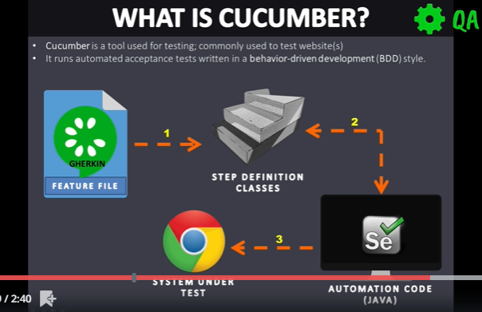
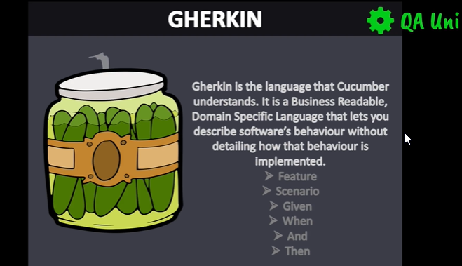
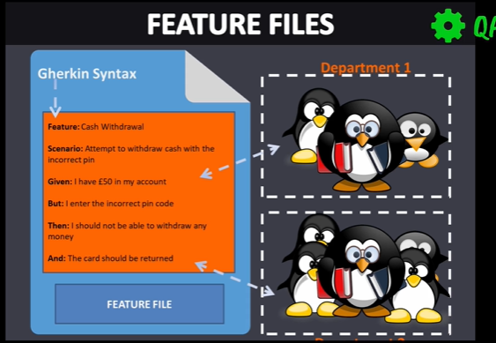
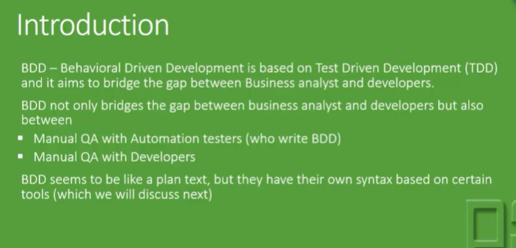
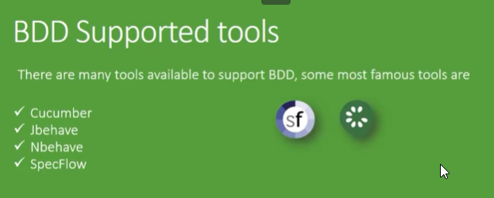
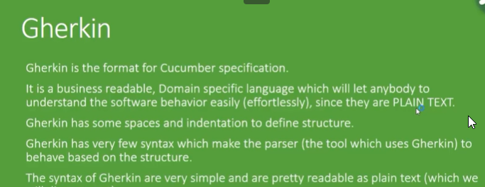
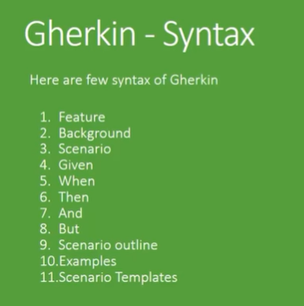
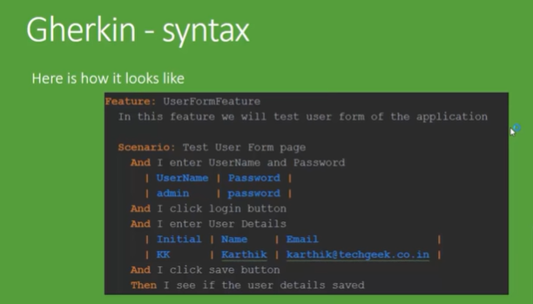
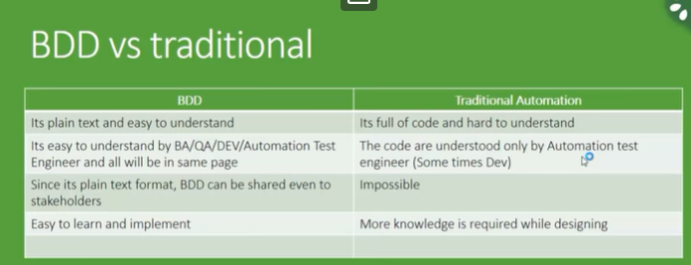
Create a feature file:
Sample feature file will look like this
Feature: Login into account
Existing stackoverflow user should be able to login into account using correct credentials

Scenario: Login into account with correct details
Given User navigates to stackoverflow website
And User clicks on the login button on homepage
And User enters a valid username
And User enters a valid password
When User clicks on the login button
Then User should be taken to the successful login page
Feature file steps should have relevant matches in the step definition file
Run feature file as Run configuration cucumber feature in the path provide the full path of the cucumber feature file and run
It will show which steps are missing step definitions.
Create a step definition file (java file) and define the steps written in the cucumber feature file
The steps should be exactly copied with the correct given, and, when, then keywords/annotations and the steps should start with ^ an end with $.
Runner class is used for generating reports. This is a sample runner class
@RunWith(Cucumber.class)

@CucumberOptions (
features = {"src/main/resources"},
glue = {"CucumberFramework.stepFiles"},
monochrome = true,
plugin = {"pretty", "html:target/cucumber",
"json:target/cucumber.json",
"com.cucumber.listener.ExtentCucumberFormatter:target/report.html"
}
)

public class MainRunner {
}
To generate the reports, run the runner class and then once the tests are completed, refresh the project, the html, json and extent reports should be generated
If we see weird characters in the console, set the monochrome option to true in the runner class, the issue should be resolved
Frameworks for testing and automation
Pre-defined framework
Junit (TDD- Test Driven framework)
TestNg (TDD- Test Driven framework)
Cucumber (BDD – Behavior Driven framework)
User-defined framework
Data Driven
Keyword Driven
Hybrid
In Test driven approach – Scenarios are converted into test cases with the help of testing annotations and we prepare and run the testing xml file and the report is generated
In BDD approach – Test Scenarios/features are written in feature files in plain English. Each feature contains a number of steps. The steps are defined/implemented in the step definition files (java file). These are run using Runner class as junit tests and it will create reports.

Install Cucumber plug-in for Eclipse
------------------------
Eclipse Market Place -->Search for cucumber -->Install

Feature File
-----------
Feature file contains all the features of an application,

Application: Ebanking
Features:
login --> Steps
add customer -->Steps
Edit customer --> Steps
------
----

To specify steps in feature file we need to use special language called Gherkins
Feature
Scenario
Given
When
And
Then

Given
Pre-requisites
When/And
Steps
Then
Expected

1) Feature file
2) Step definitions
3) TestRunner

Cucumber options
-----------------
features = the path of the feature files
glue=the path of the step definition files
format= to generate different types of reporting
eg: format={"pretty","html:test-output","json:json_output/cucumber.json","junit:junit_xml_output/cucumber.xml"}
plugin = {"pretty", "html:target/cucumber",
"json:target/cucumber.json",
"com.cucumber.listener.ExtentCucumberFormatter:target/report.html"
},
monochrome = display the console output in a proper readable format and also in a detailed format
strict = it will check if any step is not defined in step definition file
dryRun = to check the mapping is proper between feature file and step def file
the default value will be false, if it is false, the test cases will be executed, if it is made true, it should show all the steps as skipped if the mapping is correct.

--> Parameters using regular expressions

Data driven testing
----------------------------------
method-1) Scenario Outline and Examples
The scenarios will be run for different sets of data provided under examples. All the steps will be run in sequential way
method-2) Data table with single input ( with header, without header(Map))
A particular step will be run for different sets of data and only then it will go to the next step. Only that step will be run more than once, the remaining steps will be run just once.

Tags – tags is similar to the grouping feature which we use in testing, we can group sanity, regeression, endtoend and run them separately or together with tags. It’s done by mentioning @abc… on top of the scenario in the feature file. By using tagging feature we can execute/ignore specific test scenarios from a feature file.

Hooks – Before and After methods get executed after each and every scenario.
Tests
--------------
Setup --> @Before
Add new customer
tearDown -->@After

Setup
Edit customer
tearDown

Setup
Delete customer
tearDownn

